# Difference between JSON and XML

|  |  |  |
| --- | --- | --- |
| **Aspect** | **JSON** | **XML** |
| **Definition** | It is a file format that stores and transmits the data objects into human-readable text. | It is a markup language designed to store and distribute data across the web and various APIs. |
| **Full-Form** | JavaScript Object Notation | eXtensible Markup Language. |
| **Language** | Derived from javascript. | Derived from SGML. |
| **Extension** | .json | .xml |
| **Data Types** | Supports string, number, boolean, and arrays. | Data is in a string format. |
| **Tags** | No tags | Data is represented in tags. |
| **Array** | Use an array to represent the data. | Doesn’t use arrays. |
| **Comments** | Don’t support | Support |
| **NameSpace** | Don’t support | Support |
| **Orientation** | Data Oriented | Document Oriented |
| **Security** | Less Secured | More secured than JSON |

# Difference between Authentication and Authorization

|  |  |  |
| --- | --- | --- |
| **Aspect** | **Authentication** | **Authorization** |
| Definition | The process of verifying the identity of a user. | The process of determining what a user is allowed to do. |
| Objective | To ensure that the user is who they claim to be. | To control access rights and permissions to resources. |
| Key Factors | Username, password, biometrics, security tokens. | User roles, permissions, access control lists (ACLs). |
| Verification | Verifies the identity of the user. | Determines if the user has permission to access resources. |
| Occurrence | Typically occurs at the beginning of a session. | Occurs after authentication, usually before accessing resources. |
| Example | Logging into an email account with a username and password. | Accessing a file on a server that requires specific permissions. |

**Create 3 XML and JSON files for department,year,student**

#### **Department.xml:**

<departments>

<department>

<name>Computer Science</name>

</department>

<department>

<name>Electrical Engineering</name>

</department>

</departments>

#### **Year.xml:**

<years>

<year>

<number>1</number>

</year>

<year>

<number>2</number>

</year>

<year>

<number>3</number>

</year>

<year>

<number>4</number>

</year>

</years>

#### **Student.xml:**

<students>

<student>

<name>Varun</name>

</student>

<student>

<name>Teja</name>

</student>

<student>

<name>Sai</name>

</student>

</students>

#### **Department.json:**

{

"departments": [

{ "name": "Computer Science" },

{ "name": "Electrical Engineering" }

]

}

#### **Year.json:**

{

"years": [

{ "number": 1 },

{ "number": 2 },

{ "number": 3 },

{ "number": 4 }

]

}

#### **Student.json:**

{

"students": [

{ "name": "Varun" },

{ "name": "Teja" },

{ "name": "Sai" }

]

}

**Create a Login Screen using HTML**

<!DOCTYPE html>

<html lang="en">

<head>

<meta charset="UTF-8">

<meta name="viewport" content="width=device-width, initial-scale=1.0">

<title>Login</title>

<style>

body {

font-family: Arial, sans-serif;

background-color: #f4f4f4;

margin: 0;

padding: 0;

display: flex;

justify-content: center;

align-items: center;

height: 100vh;

}

.login-container {

background-color: #fff;

padding: 20px;

border-radius: 8px;

box-shadow: 0 0 10px rgba(0, 0, 0, 0.1);

}

.login-container h2 {

text-align: center;

margin-bottom: 20px;

}

.login-container input[type="text"],

.login-container input[type="password"] {

width: 100%;

padding: 10px;

margin-bottom: 15px;

border: 1px solid #ccc;

border-radius: 5px;

box-sizing: border-box;

}

.login-container input[type="submit"] {

width: 100%;

padding: 10px;

border: none;

border-radius: 5px;

background-color: #007bff;

color: #fff;

font-size: 16px;

cursor: pointer;

}

.login-container input[type="submit"]:hover {

background-color: #0056b3;

}

</style>

</head>

<body>

<div class="login-container">

<h2>Login</h2>

<form action="#" method="post">

<input type="text" name="username" placeholder="Username" required>

<input type="password" name="password" placeholder="Password" required>

<input type="submit" value="Login">

</form>

</div>

</body>

</html>

**OUTPUT**

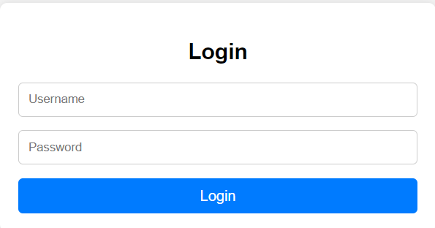

**Create a HTML page with Video file**

<!DOCTYPE html>

<html lang="en">

<head>

<meta charset="UTF-8">

<meta name="viewport" content="width=device-width, initial-scale=1.0">

<title>Video Player</title>

</head>

<body>

<h2>My Video</h2>

<!-- Replace the src attribute with your YouTube video's embed URL -->

<iframe width="560" height="315" src="https://www.youtube.com/embed/xJvgC40JGsM?si=sXYYiRu7fFL7PXmO" title="YouTube video player" frameborder="0" allow="accelerometer; autoplay; clipboard-write; encrypted-media; gyroscope; picture-in-picture; web-share" referrerpolicy="strict-origin-when-cross-origin" allowfullscreen></iframe

</body>

</html>

**OUTPUT**

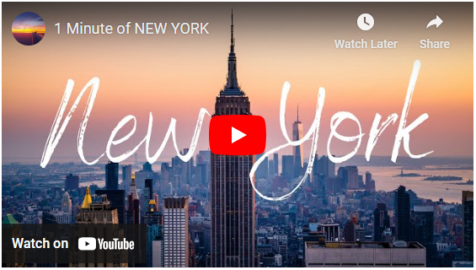

**Create a HTML page with Audio file**

<!DOCTYPE html>

<html lang="en">

<head>

<meta charset="UTF-8">

<meta name="viewport" content="width=device-width, initial-scale=1.0">

<title>Audio Example</title>

</head>

<body>

<h1>My Audio</h1>

<audio controls>

<source src="**audiofile.mp3**" type="audio/mp3">

Your browser does not support the audio element.

</audio>

</body>

</html>

**Create a HTML page to upload a file**

<!DOCTYPE html>

<html lang="en">

<head>

<meta charset="UTF-8">

<meta name="viewport" content="width=device-width, initial-scale=1.0">

<title>File Upload</title>

</head>

<body>

<h1>Upload a File</h1>

<form action="#" method="post" enctype="multipart/form-data">

<input type="file" name="file" id="file">

<input type="submit" value="Upload">

</form>

</body>

</html>

**OUTPUT**

